Activity 1.1: Documents through time

Look closely at the three documents. Compare and contrast them and then answer the questions.
Document 1: Handwritten, using a pen and paper
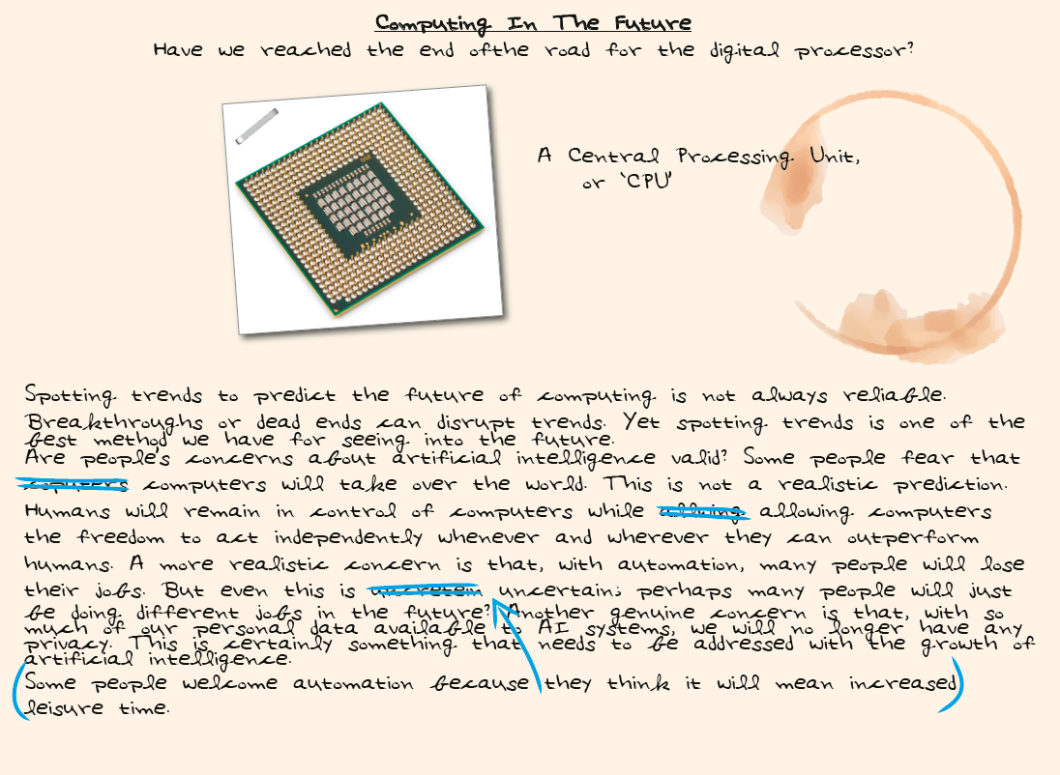

Document 2: Typewritten, using a mechanical typewriter
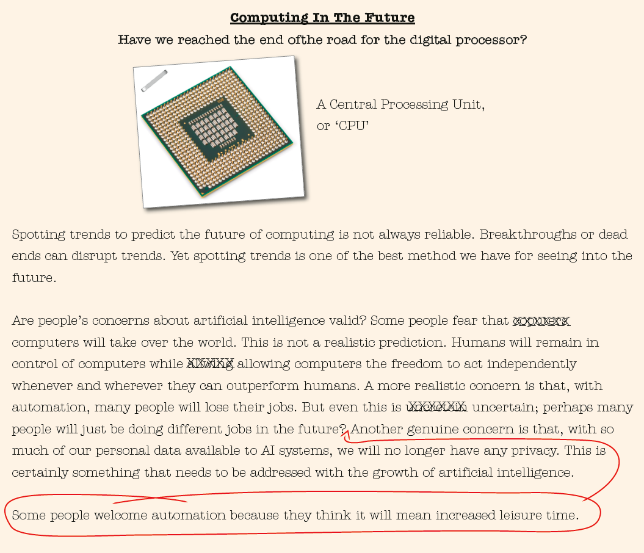

Document 3: Word processed, using a personal computer
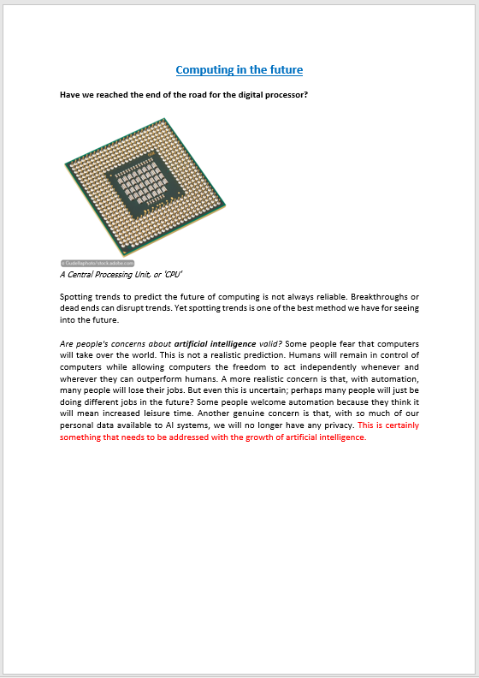

- Documents are designed to communicate information.
What features of Document 1, the handwritten document, make it difficult to understand what it is trying to communicate?

- Compare Documents 1 and 2. What improvements to written communication did
the typewriter bring?

- Compare Documents 2 and 3. What improvements to written communication did the word processor bring?
Think about all the things a person using a word processor can do that a person using a typewriter cannot do.

